


The Fifth Lloyd’s Register Educational Trust Lecture

14 November 2011 (Monday) at 7p.m.
Engineering Auditorium, National University of Singapore

Maritime and Ocean Technologies - A View to the Horizon

Mr Peter G. Noble
Distinguished Practitioner - Naval Architecture & Ocean Engineering

Abstract
We live on a planet which might better be named “Ocean” rather than “Earth”. Seventy percent of the surface is covered by water and it has been reported that over eighty percent of life forms exist in its seas. And yet we have only explored a small fraction of this water world.
From pre-historic times the seas and oceans have connected mankind and still do, providing the main means of international commerce through the transport of raw materials and manufactured products. For most of history the seas have provided a ready source of food and in more recent times we have been able to develop technology to extract energy from below the oceans at ever increasing water depths and challenging frontier areas such as the Arctic.
This lecture will look at a number of scenarios and explore how maritime and ocean technology may play a part in realizing the future of our planet.
This future will depend on people and so the potential for a new paradigm for the education and training of naval architects, marine and ocean engineers and technologists, will be discussed. And people will need tools to do this work, so the possible development of new facilities and systems for development prototyping, manufacturing and operations will also be presented
The future scenarios will look at both the evolution of existing ocean activities and the development of new ways to use our seas to provide energy, food and raw materials in a sustainable way.

About the Speaker

For more than 40 years, Peter Noble has worked internationally as a naval architect and ocean engineer. His career has included positions in design and construction of ships and ocean systems, research and development, and in classification. He currently serves as Chief Naval Architect at ConocoPhillips, the international energy company.
A continuing focus of his professional work has been related to innovation and technology development and he has published widely on a range of maritime and offshore technology topics.
In 1993 Peter was awarded the “SNAME Centennial Medal” and in 2006 SNAME honored him by awarding the Admiral Jerry Land Medal for “contributions to the marine industry”. In 2009 he was recognized by the Offshore Technology Conference, OTC, with the prestigious Distinguished Achievement Award for Individuals, based on his work in two fields, LNG and Arctic Engineering and for his continuing contributions to young professionals.
He is a Fellow and Vice President of the Society of Naval Architects and Marine Engineers and has recently been nominated as the next president of that Society.

Lecture is open to the public. Please register with Ms Norela Buang via online

Organised by Centre for Offshore Research & Engineering, NUS

The Lloyd's Register Educational Trust (The LRET) is an independent charity working to achieve advances in transportation, science, engineering and technology education, training and research worldwide for the benefit of all

Supporting Organizations:

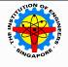
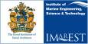


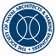

REPLY SLIP

To: Centre for Offshore Research & Engineering
(Attn: Ms Norela Buang, Fax: 65-67791635, Email: ceenb@nus.edu.sg)

The Fifth Lloyd’s Register Educational Trust Lecture

Maritime and Ocean Technologies - A View to the Horizon

Mr Peter G. Noble
Distinguished Practitioner - Naval Architecture & Ocean Engineering

Monday, 14 November 2011
Engineering Auditorium, NUS at 7pm
Registration starts from 6.30pm

For Registration:

Click here

For viewing http://www.eng.nus.edu.sg/core/ (upcoming column)

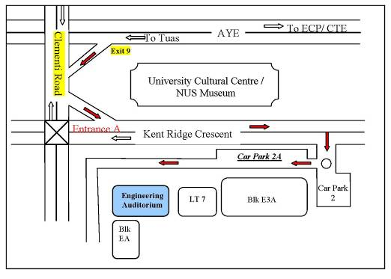
Location map of Engineering Auditorium, National University of Singapore

